6.6 Reference Subsystem Flowcharts

The following sections contain batch process flowcharts for the Reference Subsystem. The flowcharts included in this section are:

- Parameter Reporting process 1
- Parameter Reporting process 2 (Selective Drug)
- PDCS Drug Interface process
- Drug State MAC Pricing Interface process
- HCPCS Annual Update Interface process
- HCPCS Quarterly Add process
- HCFA Mandate Interface process
- DME Update Interface process
- DRUG Average Sales Price (ASP) Quarterly Update Process
- Clinical Diagnostic Laboratory (CDL) Update Process
- CPT Fee Schedule Adjustments Update Process
- Pricing updates

The flowcharts listed above begin on the next page.

Parameter Reporting Process 1
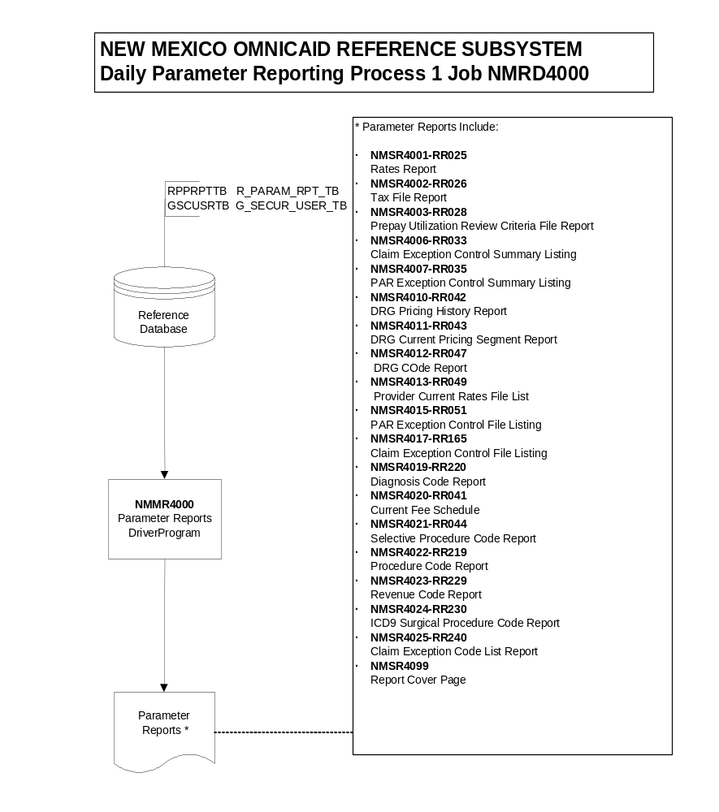

Parameter Reporting Process 2 (Selective Drug)

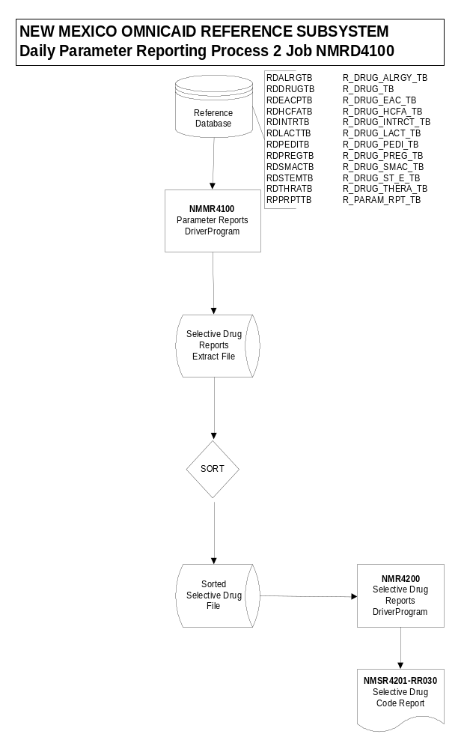

PDCS Drug Interface Process

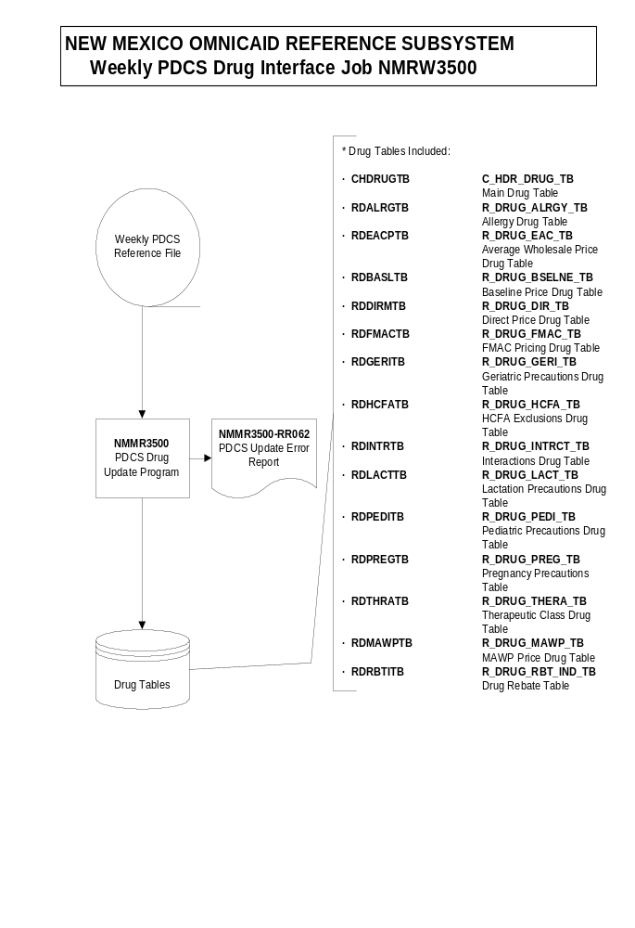

Drug State MAC Pricing Interface Process

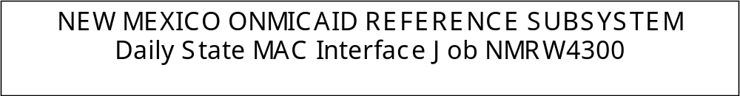

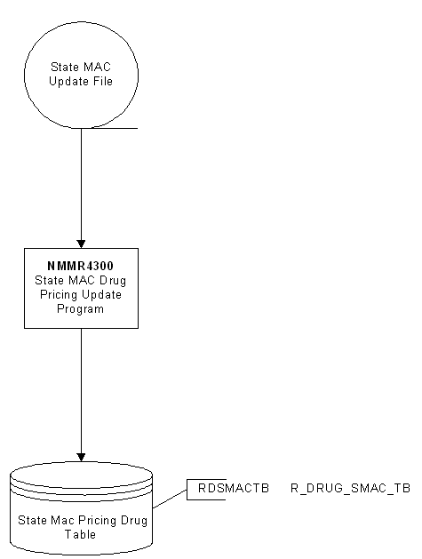

HCPCS Annual Update Interface Process
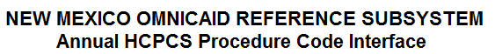
JOBS: NMRA3400 / NMRR3410 / NMRA3200


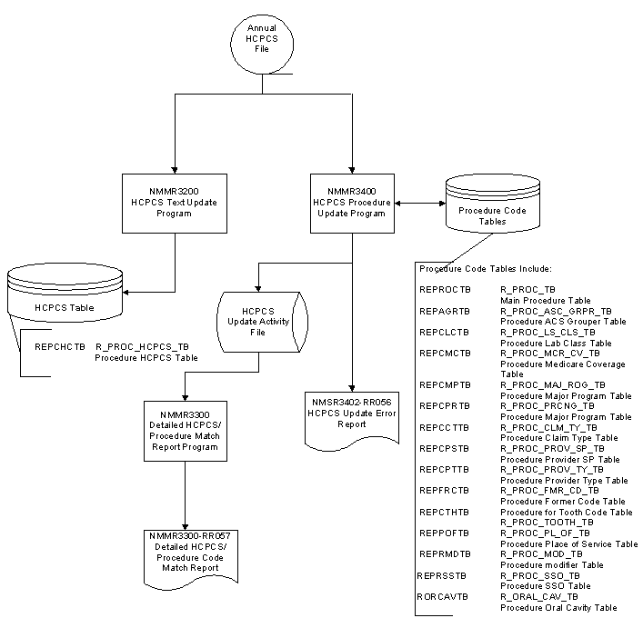

HCPCS Quarterly Add Interface Process

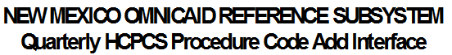
Job: NMRQ3415
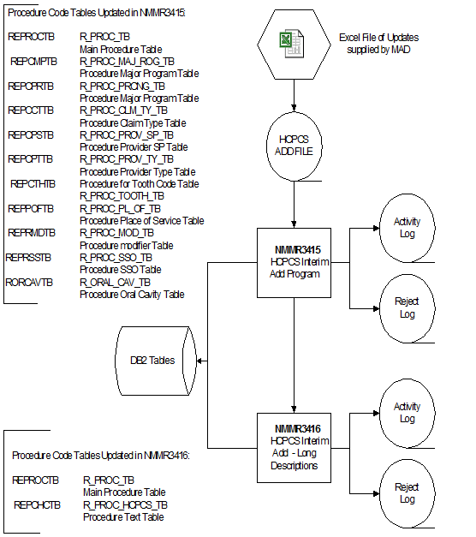

CDL Fee Schedule Update

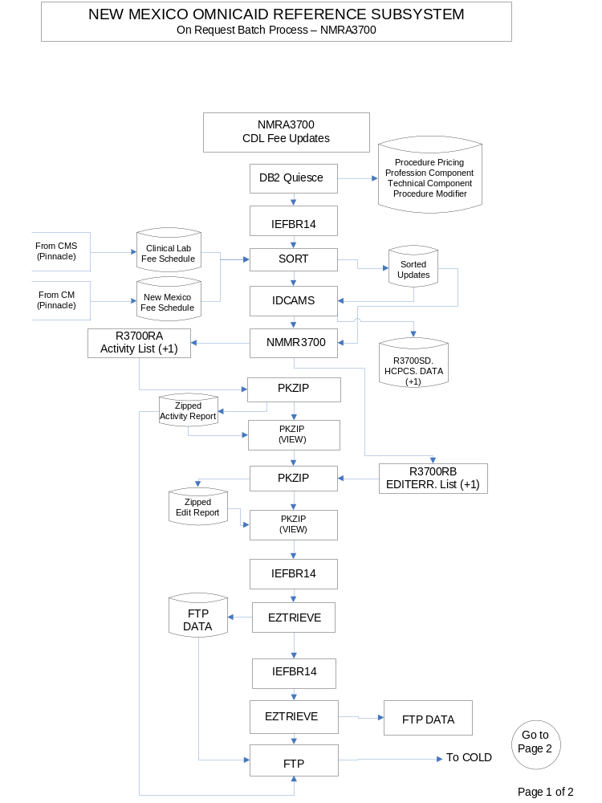

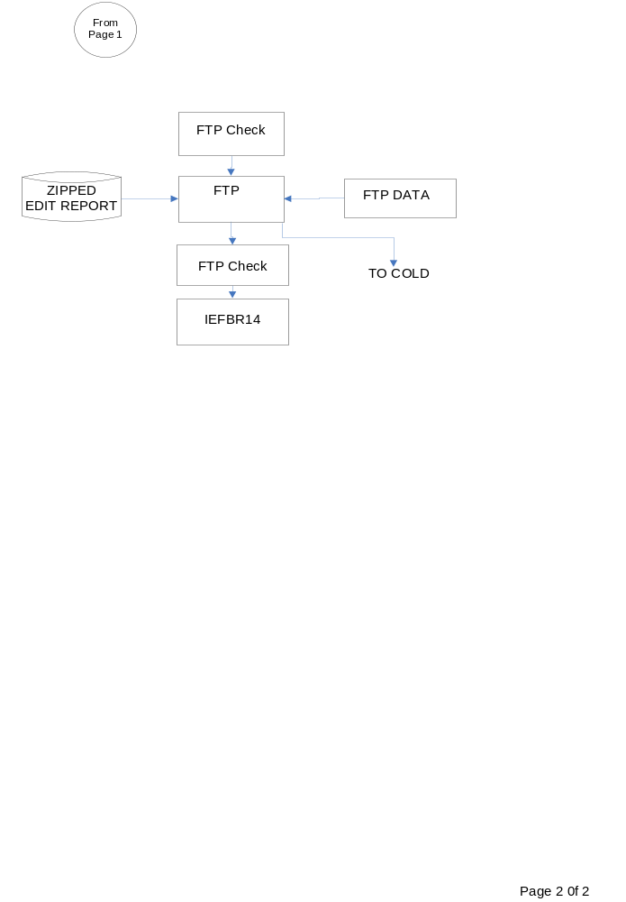
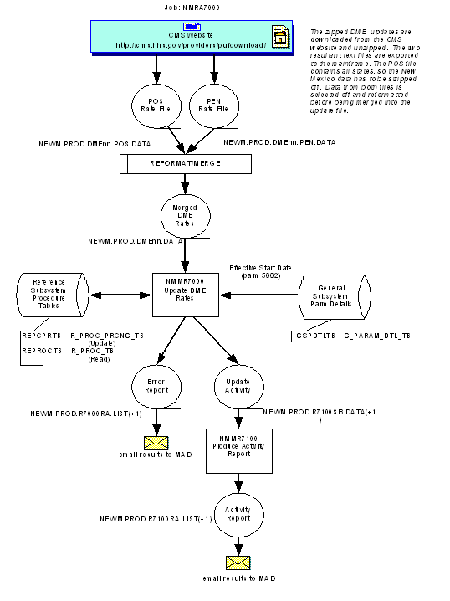

DRUG Average Sales Price (ASP) Quarterly Update Process

Clinical Diagnostic Laboratory (CDL) Update Process

CPT Fee Schedule Adjustments Update Process

Pricing Updates

